Video for the Analysis

Instructions and tips for capturing a video

The better will be your video footage, the better will be our output - the analysis. A good quality video footage will provide us with more information that is needed to process the objective and accurate analysis.

Please follow the instructions and tips listed below.

Instructions
- Always capture your strokes in landscape mode. This means that the camera/phone is wider than it is longer.

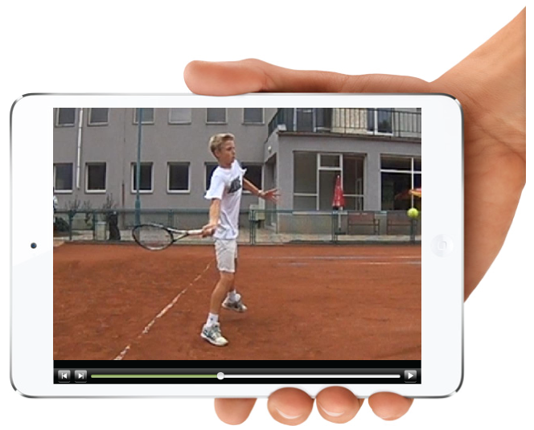

For an ideal video footage, the player should take up roughly 1/3 of the total screen area. There should be only a little space over your head (except when shooting video of your serve, where you want to be able to see ball contact overhead, so there will be more space visible overhead).
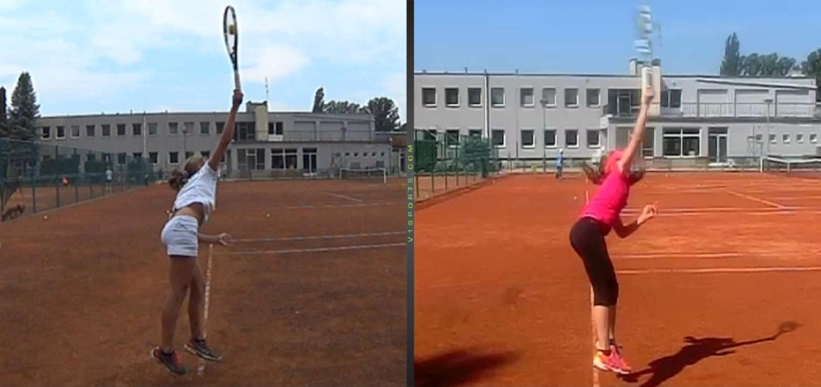

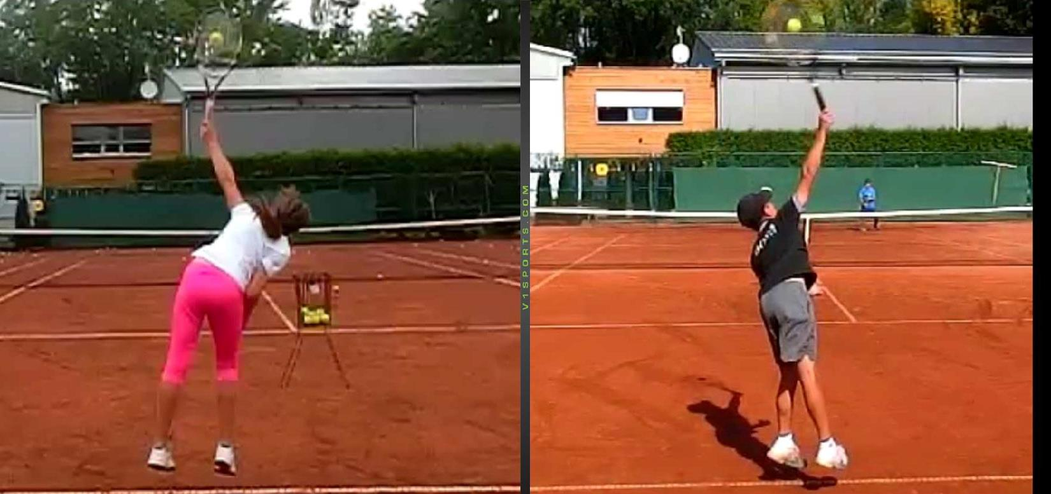

We recommend that you take 5 minutes of shooting for each stroke.

- Shoot the video with the highest number of frames per second. We recommend 240 fps and more. (fps – frames per second)
- Shoot the video in good light conditions. The best quality high-speed videos will be shot outdoors in full sunlight, no night videos.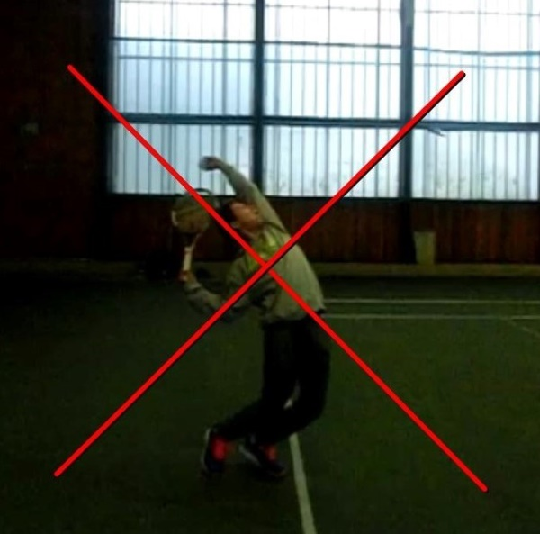
- We strongly recommend that you use a tripod for your camera, mobile phone, or tablet when shooting a video. Moving video is not suitable for analysis purposes. Set the tripod such that the camera pointing somewhere between your waist and shoulder level.
- Place the camera or mobile phone in the following positions:

- side view - perpendicular to the point where the stroke is taken (the baseline or the net), so you can see your entire stroke movement from the side
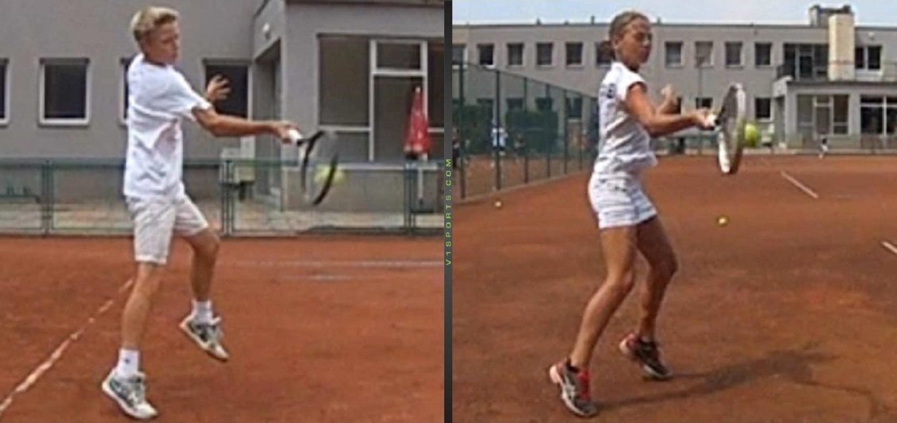
- back view - parallel to the baseline, behind the point where the stroke is taken, so you can see your entire stroke movement from the back
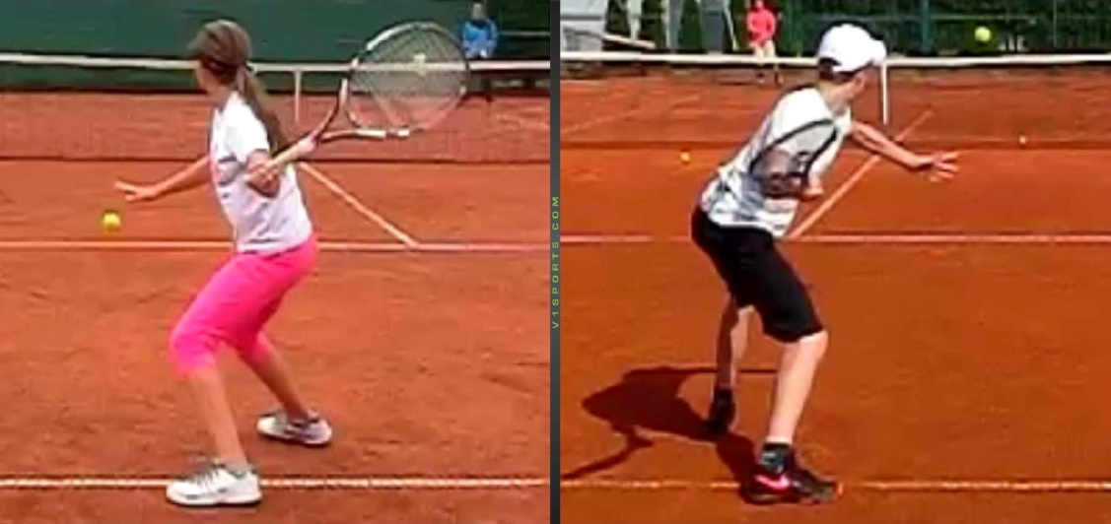
- When shooting a video, avoid any shifts and moves with your camera, mobile phone or tablet. ("Don't follow" player's movement.)

